Calculation of Inverse Matrix:

1. Using Gauss-Jordan reduction:

The procedure for computing the inverse of a matrix A:

- Form the 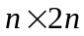 augmented matrix
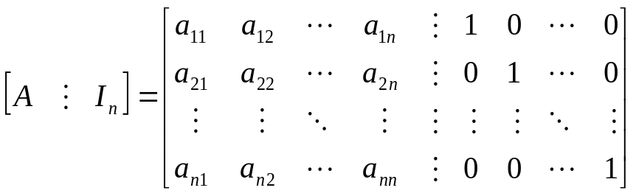
and transform the augmented matrix to the matrix

in reduced row echelon form via elementary row operations.

- If
(a) 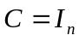, then 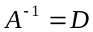.
(b) 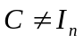, then  is singular and  does not exist.

Example:

To find the inverse of 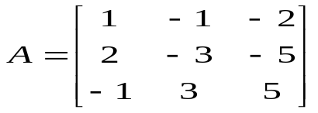, we can employ the procedure introduced above.

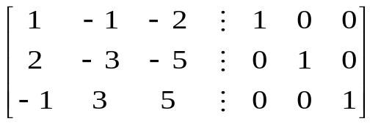.
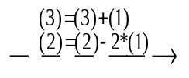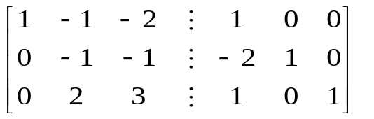
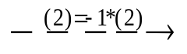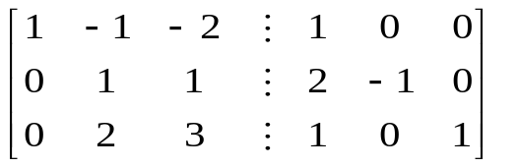
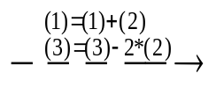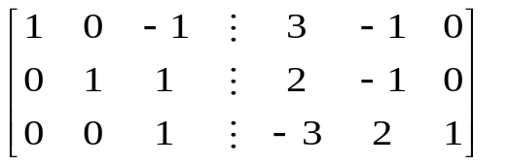
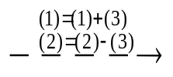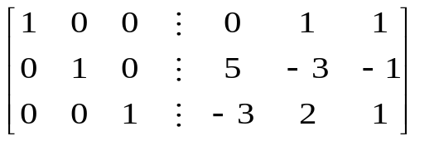

- The inverse of A is
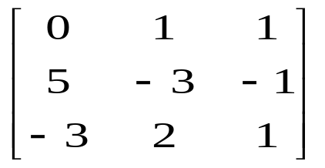.

Example:
Find the inverse of 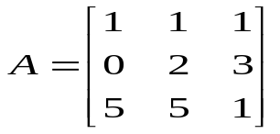if it exists.

[solution:]

1. Form the augmented matrix
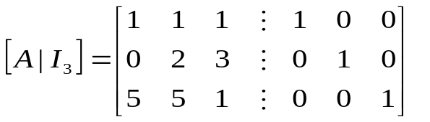.
And the transformed matrix in reduced row echelon form is
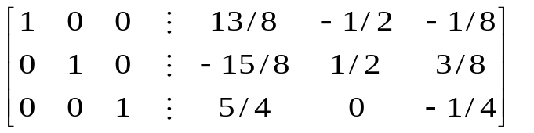

2. The inverse of A is
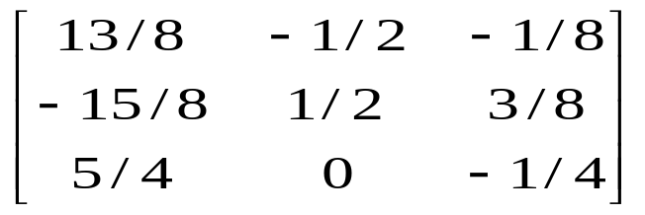.

Example:
Find the inverse of 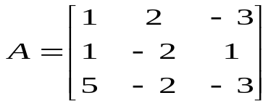if it exists.

[solution:]

1. Form the augmented matrix
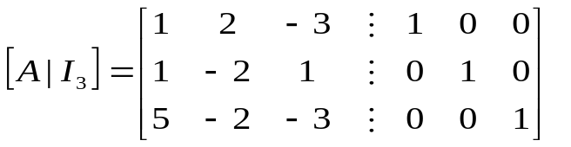.
And the transformed matrix in reduced row echelon form is
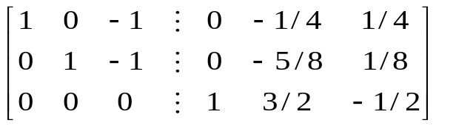

2. A is singular!!

2. Using the adjoint 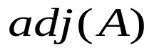 of a matrix:

As 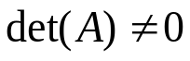, then
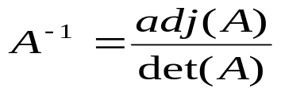.
Note:
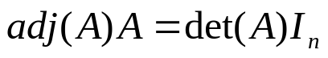 is always true.
Note:
As  A is nonsingular.

